**DOCUMENT HISTORY AND INFORMATION**

**History of Amendments:**

|  |  |  |  |  |
| --- | --- | --- | --- | --- |
| **Date** | **Version** | **Modified Section** | **Summary of Change** | **Author** |
| 23/06/09 | 0.1 | ALL | Initial Draft | John Jacobi |
|  |  |  |  |  |
|  |  |  |  |  |
|  |  |  |  |  |

**Distributed for Review**

This document has been distributed for the following to review:

|  |  |  |  |
| --- | --- | --- | --- |
| **Name** | **Title & Company** | **Issue Date** | **Revision** |
|  |  |  |  |

**Approvals**

This document requires the following approvals:

|  |  |  |  |
| --- | --- | --- | --- |
| **Name** | **Signature** | **Title** | **Issue Date** |
|  |  |  |  |
|  |  |  |  |
|  |  |  |  |
|  |  |  |  |
|  |  |  |  |

**Associated Documents**

This document is associated with the following other documents:

|  |  |  |  |  |
| --- | --- | --- | --- | --- |
| **Name** | **Title and Originator’s Reference** | **Source** | **Issue Date** | **Version** |
|  |  |  |  |  |

**Table of contents**

**1** **Introduction 5**

**2** **Purpose 5**

**3** **Scope 5**

**4** **Definitions, Acronyms and Abbreviations 5**

**5** **Overview 5**

**5.1** **Use case diagram 5**

**5.2** **Entity relationship diagram 6**

**6** **Functionality Requirements 7**

**6.1** **Logon & Logout 7**

**6.2** **Organisations 7**

6.2.1 List Organisations 7

6.2.2 Add Organisation 8

6.2.3 Amend Organisation 12

6.2.4 Mark In-active Organisation 14

6.2.5 Supporting Materials Maintenance 14

List Supporting Materials 14

Add Supporting Materials 15

Amend Supporting Materials 15

Mark In-active a Supporting Materials 15

6.2.6 Directorate Maintenance 15

List Directorates 16

Add Directorate 16

Amend Directorate 17

Mark In-active a Directorate 17

6.2.7 Department Maintenance 17

List Departments 17

Add Department 18

Amend Department 18

Mark In-active a Department 18

6.2.8 Team Maintenance 18

List Teams 19

Add Team 20

Amend Team 20

Mark In-active a Team 20

**6.3** **Services 20**

6.3.1 List Service 20

6.3.2 Add Service 22

6.3.3 Amend Service 26

6.3.4 Mark In-active Service 28

6.3.5 Programme 28

List Programmes 28

Add Programme 28

Amend Programme 29

Mark In-active Programme 29

**6.4** **Geography 29**

6.4.1 Trust Region Maintenance 29

List Trust Regions 29

Add Trust Region 30

Amend Trust Region 30

Mark In-active Trust Region 30

6.4.2 Trust District Maintenance 31

List Trust Districts 31

Add Trust District 31

Amend Trust District 31

Mark In-active Trust District 31

6.4.3 Government Office Region 32

List Government Office Region 32

View Government Office Region 32

**6.5** **Premises 32**

6.5.1 List Premises 32

6.5.2 Add Premise 33

6.5.3 Amend Premise 38

6.5.4 Mark In-active Premise 38

6.5.5 Facility Maintenance 39

6.5.6 Volunteering Opportunity 40

6.5.7 Minor Work Projects 41

6.5.8 Services 43

**6.6** **Contacts 44**

6.6.1 List Contacts 44

6.6.2 Add Contacts 44

6.6.3 Edit Contacts 45

**6.7** **Address lookup 45**

**6.8** **Type of Business lookup 46**

**7** **Non-functional requirements 47**

**7.1** **Performance 47**

**7.2** **Scalability 48**

**7.3** **Security 48**

**7.4** **Portability 48**

**7.5** **Audit 48**

**7.6** **Error handling 48**

**7.7** **Infrastructure 49**

**7.8** **Look and feel 49**

**7.9** **Legal 49**

**7.10** **Training 49**

**7.11** **User Documentation & Help Screen Requirements 49**

**7.12** **Support & Supportability 49**

**7.13** **Reliability 50**

**7.14** **Design Constraints 50**

**7.15** **Purchased Components 50**

**7.16** **Interfaces 50**

**7.17** **Test 50**

**7.18** **Data 50**

# **Introduction**

AB currently does not have a central repository for the services that they (and associated) organisations provide. This system requirements specification is part of the project to deliver a central repository called the Services Directory.

# **Purpose**

This document details the functional (within Use Case documents) requirements and non-functional requirements for the Services Directory.

NB In early versions of this document many of the requirements are stated as <TBD>, this means To Be Detailed>. At the point of writing the version then this requirement needs further discussion /investigation or analysis before it can be documented.

# **Scope**

The scope of this document is for the Services Directory, this will include any interfaces that are required.

# **Definitions, Acronyms and Abbreviations**

<TBD>

# **Overview**

## **Use case diagram**

The following use cases are required to be to be included in the Service Directory

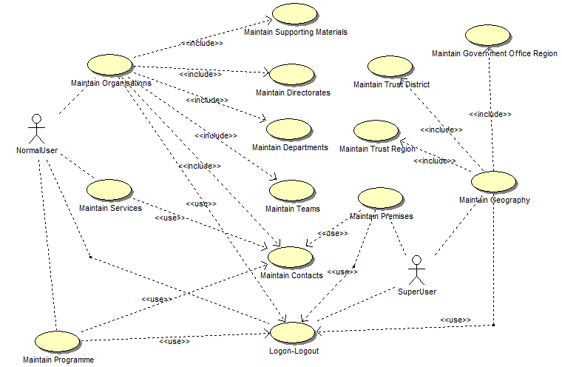

|  |  |  |
| --- | --- | --- |
| **UC** | **Name** | **Description** |
| UC001 | Logon & Logout | Allowing a user to logon to the system |
| UC002 | Maintain Organisations | Maintain the data within the Organisation area of the system |
| UC003 | Maintain Services | Maintain the data for Services |
| UC004 | Maintain Programmes | Maintain the data for Programme |
| UC005 | Maintain Premises | Maintain the data for premises, facilities and persons |
| UC006 | Maintain Geographic Data | Maintain the data within the Geography area of the system |

## **Entity relationship diagram**



|  |  |  |
| --- | --- | --- |
| **#** | **Entity** | **Description** |
| 1 | Organisation | List all organizations that involved with AB services |
| 2 | Directorate | A unit (which for AB will have a Chief Officer (C.O.) (e.g. Finance, W&I))) |
| 3 | Department | A unit run by a direct report of a C.O. (e.g. Health & Well Being, Financial) |
| 4 | Team | A unit that reports to a Department Head (e.g. Payroll, Equality & Diversity) |
| 5 | Contact | Storing all contacts in the system |
| 6 | Service | List all services |
| 7 | TrustRegion | An AB-created geographical area covering one or more County and broken down into Trust Districts. |
| 8 | TrustDistrict | An AB-created area which is part of a AB Trust Region. |
| 9 | Country | List all Nation Countries in the system |
| 10 | County | List all County in the system |
| 11 | Town | List all Towns in the system |
| 12 | Address | List all addresses used in the system |
| 13 | User | List all User of the system |
| 14 | ReferenceData | List all reference data used in the system |
| 15 | SupportingMaterial | Supporting materials for Organizations |
| 16 | Programme |  |
| 17 | Premise |  |
| 18 | GovOfficeRegion |  |

# **Functionality Requirements**

## **Logon & Logout**

User would enter User name and Password to login the system.

If user forgets password, he/she can click on ‘Forgot Password’ link on the Logon page. The screen will be displayed allowing user to input Username and Email to retrieve password. If Username and Email are not fit, error message will display ‘Username and Email do not match’. Otherwise, system will send password to the email input.

**Menu**

Four first items on the left menu will be in scope of Phase 1:

* Organisation
* In “Services” module, there are two functions:
* Programme Maintenance
* Service Maintenance
* In “Geography” module, there are four functions:
* Trust Regions/Trust Districts Maintenances
* Government Office Region – List and View
* Premises

## **Organisations**

### **List Organisations**

By clicking on ‘Organisations’ from the menu, ‘Organisation List’ screen is displayed showing all active Organisations by default. The list is paging with 15 records showing in one page.

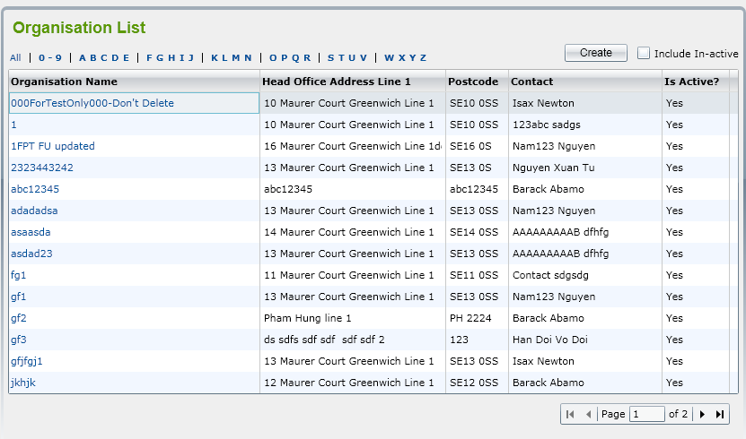

If user clicks on ‘Include In-active’ checkbox, all of active and in-active Organisations will be displayed in the list.

User can filter Organisations by selecting ‘All’ or ‘0-9’ or ‘ABCDE’ or ‘FGHIK’, etc. in a row above the list. -> All Organisations that begin with the selected letter will be shown.

User can sort Organisations by clicking on column name.

If user selects an Inactive Organisation in the list to view, the system will display message “Do you want to make this Organization active?” with 2 buttons: OK and Cancel

* If clicking on ‘OK’ button, ‘Organisation Details’ screen is opened and system will automatically change status of Organisation from Inactive to Active
* If clicking on ‘Cancel’ button, it keeps ‘Organisation List’ screen showing and status of selected Organisation is still inactive.

**NOTE: Above listing, filtering, sorting and marking an in-active record to active behaviors are standard features in a list screen in the whole system.**

### **Add Organisation**

If user clicks on ‘Create’ button on the ‘Organisation List’ screen, ‘Organisation Details’ screen is displayed including two tabs: Details 1 and Details 2 to allow user to enter Organisation fields for new one.

* Below is illustration of Details 1 tab:

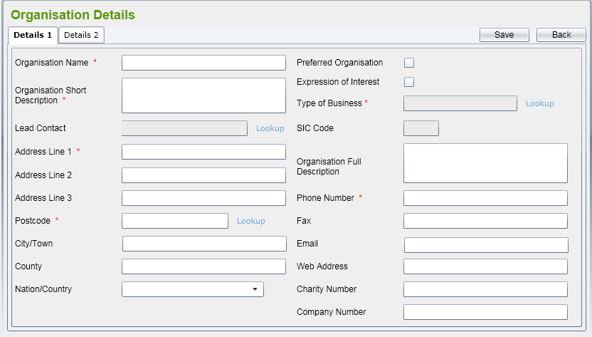

By default, all of fields should be blank, all check boxes should be un-ticked.

There are some rules on this screen:

* Mandatory fields
  + Organisation Name
  + Organisation Short Description
  + Type of Business
  + Address Line 1
  + Postcode
  + Phone Number
* Unique fields
  + Organisation Name
* Lead Contact lookup will display all contacts in the system in a pop-up window. Refer to Contacts for more details.
* Postcode lookup will display all addresses retrieved from database in a pop-up window. Refer to Address for more details
* Type of Business lookup will display all SIC Code data that already listed in reference data. Refer to Type of Business for more details;

After selecting a Type of Business from pop-up window, related SIC Code will be populated to the text box under Type of Business automatically.

* Nation/Country will list all of Country get from reference data.
* If user manually enters Postcode value, the system will check whether it is existing in the database or not. If not, prompt message should be displayed as 'Address Details cannot be confirmed - Do you wish to enter Unconfirmed Address Data (Y/N?)'. If user clicks No (Cancel), postcode should be focused again and the previous value should be cleared out.
* ‘Details 2’ tab should be as below:

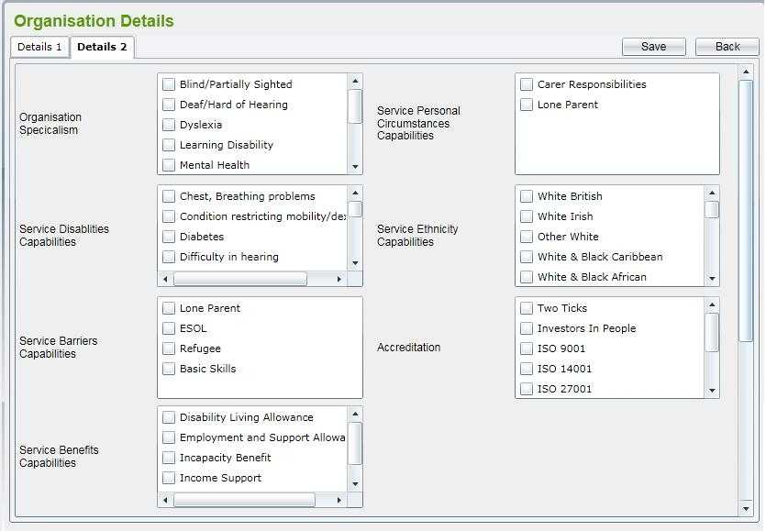

All of list boxes in this tab get from reference data.

If user clicks on ‘Expression of Interest’ checkbox in ‘Details 1’ tab, ‘Detail 3’ tab is displayed and navigated automatically.

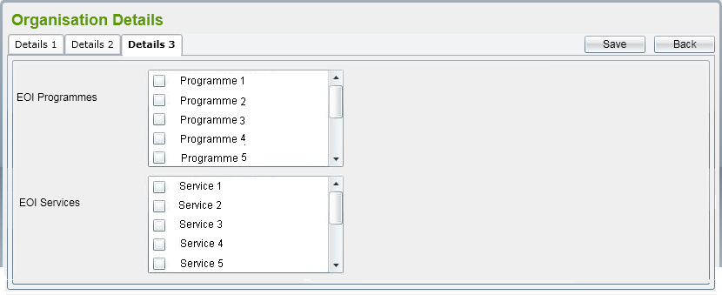

In this screen, it will list all of active Programmes and Services in the system to link.

To save Organisation record, user should click on ‘Save’ button on the screen. The system will validate mandatory fields are already input or not and check if Organisation Name is existed in the system.

If some mandatory fields are not input, error message(s) should be displayed and adding is aborted.

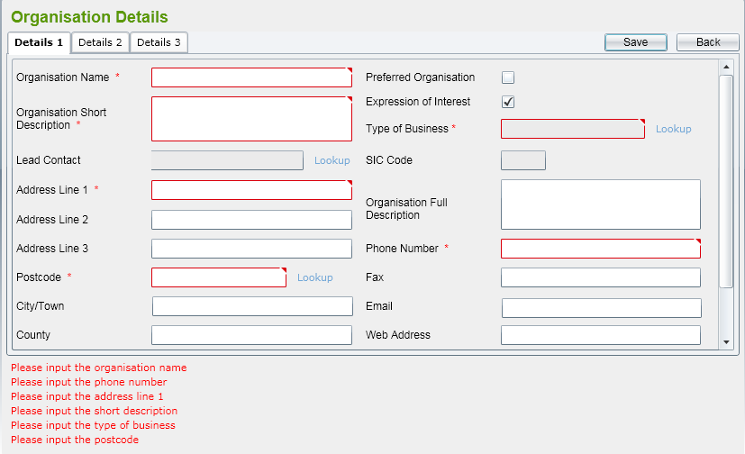

If the validation is passed, Organisation record will be saved and Organisation details screen is kept to allow user to add Directorates for this Organisation. Message to inform the successful saving should be displayed as well.

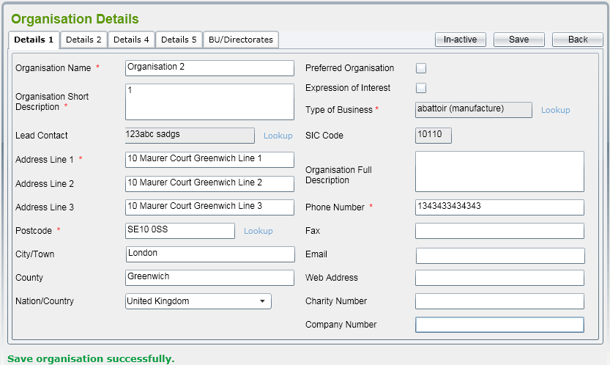

* If user clicks on ‘Back’ button, it will come back to the Organisation List screen.

**NOTE: It is a standard behavior in the whole system. After user clicks on ‘Back’ button in a Details screen, the related List screen should be shown.**

### **Amend Organisation**

By selecting an active Organisation from the list, the Organisation Details screen is displaying allowing user to amend. User can amend all of fields showing in tabs. In ‘Amend’ mode, three additional tabs should be shown:

* Details 4:

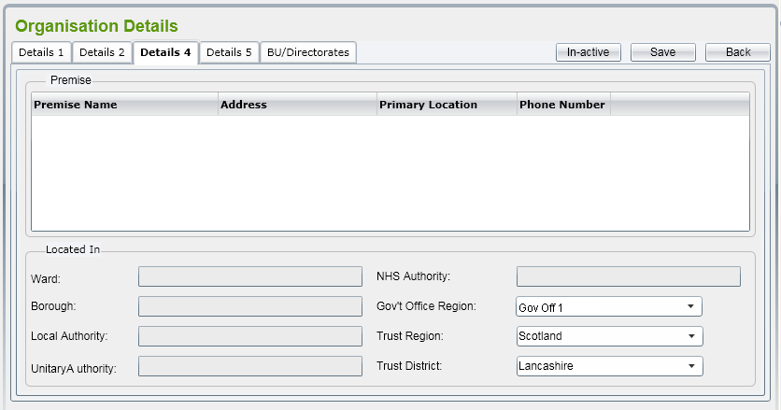

This tab to show all premises already link to Organisation. The link is created in Premises module.

There are some additional fields which are retrieved from POSTZON system relates to Organisation postcode: Ward, Borough, Local Authority, Unitary Authority and NHS Authority. They all should be read-only.

The Government Office Region (GOR) dropdown list will contain all of GOR already link to Organisation’s county (input in Details 1 tab). The screen also displays Trust Region and Trust District to allow user to select for Organisation.

* Details 5:

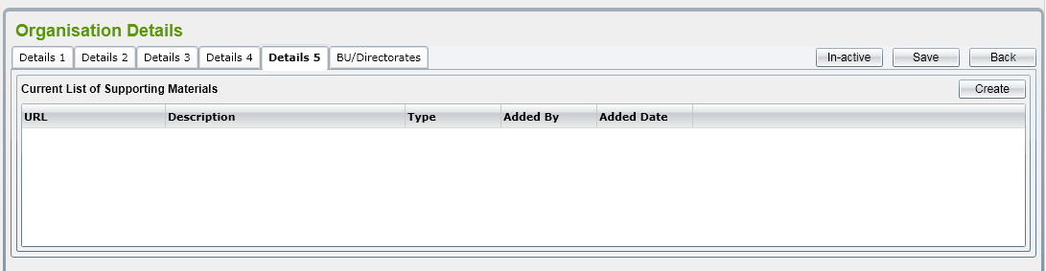

This tab maintains Supporting Materials for the Organisation. User can add, amend, and mark in-active for an external supporting materials.

Refer to Supporting Materials Maintenance for more details.

* BU/Directorates:

This tab maintains Directorates and its children Department/Team for the Organisation. User can add, amend, and mark in-active for these entities.

Refer to Directorate Maintenance for more details.

If user changes an Address field, during the validation after clicking on ‘Save’ button, a message (“The Address has been changed, do you want to save new Address?”) will be displayed to get confirm that user really wants to change Address or not. If not, old Address values will be kept.

### **Mark In-active Organisation**

User can mark an Organisation to in-active by clicking on ‘In-active’ button on the details screen. If the Organisation already links to a Service or a Premise, the prompt message “This Organization is already in use, do you want to make this in-active?” should be displayed with two buttons “OK” and “Cancel”

If user clicks on ‘OK’ button, the organisation will be changed status to ‘In-active’. Otherwise, it still keeps being ‘Active’.

After an Organisation has been changed to ‘In-active’, all of its Directorates, Departments and Teams still keep their status. The in-active process is not cascade.

### **Supporting Materials Maintenance**

This function includes following screen:

* List Supporting Materials
* Add Supporting Materials
* Amend Supporting Materials
* Mark In-active Supporting Materials

They will be described in more details in sections below

#### **List Supporting Materials**

This list should look like as below:

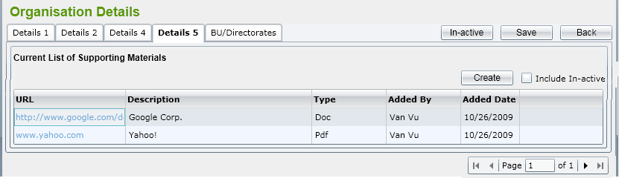

The list should have standard behavior such as:

* Displaying active records by default but user can list in-active records as well
* Sorting
* Paging (15 records in a page)
* Marking in-active record to active. The prompt message should be “Do you want to make this Supporting Materials active?”

#### **Add Supporting Materials**

Illustration screen should be:

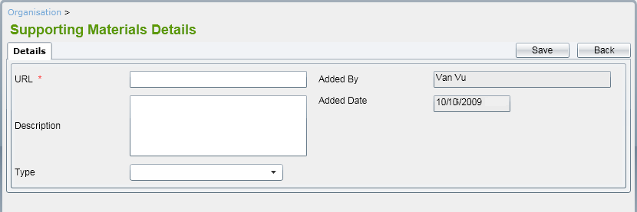

In which:

* URL is mandatory field
* Type could be Doc / PDF / Excel
* Added By and Added Date are read-only fields which showing current user name and current date.

#### **Amend Supporting Materials**

In ‘Edit’ mode of a Supporting Materials, use can edit URL, Description and Type fields.

#### **Mark In-active a Supporting Materials**

In Supporting Materials details screen, there is ‘In-active’ button that enable user to mark a record to in-active.

### **Directorate Maintenance**

This function includes following screen:

* List Directorates
* Add Directorate
* Amend Directorate
* Mark In-active Directorate

They will be described in more details in sections below

#### **List Directorates**

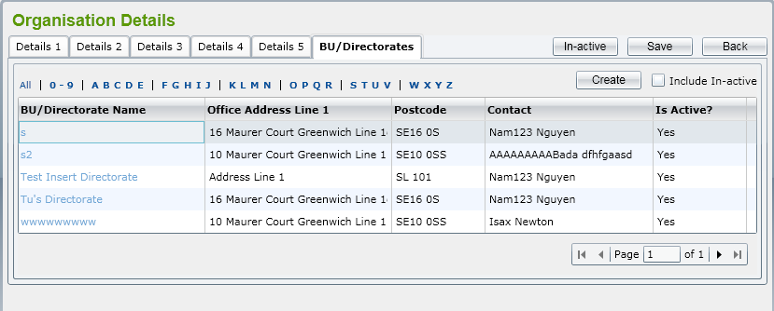

Similar to other list, this should have standard behaviors: displaying active/in-active, filtering, sorting, paging and marking an in-active Directorate to active.

The prompt message when user selecting an inactive record to view should be “Do you want to make this BU/Directorate active?”

#### **Add Directorate**

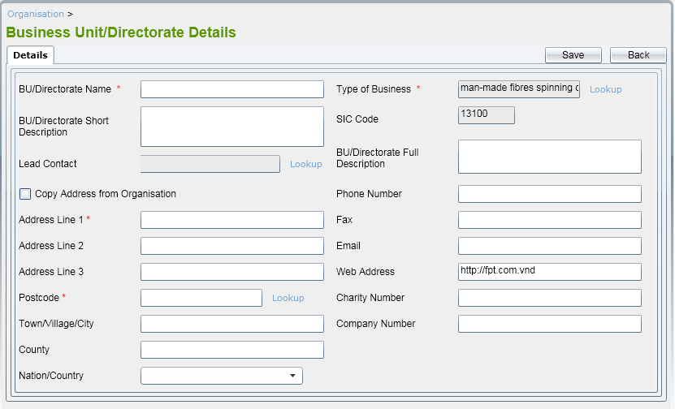

In BU/Directorate details screen, following fields should be mandatory:

* BU/Directorate Name
* Type of Business
* Address Line 1
* Postcode

Besides, BU/Directorate Name should be unique.

When creating a Directorate, by default, Type of Business, SIC Code and Web Address fields should have the same values from Organisation that has this Directorate. However, user can change them to other values.

User can tick on ‘Copy Address from Organisation’ check box and then all Address fields will be populated value from Organisation’s address fields.

Three lookups including Type of Business, Lead Contact and Postcode are the same as Organisation’s.

The validation of Address fields is the same as in Organisation maintenance.

#### **Amend Directorate**

All fields in ‘Details’ tab can be editable. Validation rules are the same as adding Directorate.

Besides, there should be ‘Departments’ tab displaying. Refer to List Departments for more details.

#### **Mark In-active a Directorate**

User can mark a Directorate to ‘In-active’ by clicking on ‘In-active’ button on amend Directorate screen.

After a Directorate has been changed to ‘In-active’, all Departments and Teams belonging to that Directorate still keep their status. The in-active process is not cascade.

### **Department Maintenance**

This function includes following screen:

* List Departments
* Add Department
* Amend Department
* Mark In-active Department

They will be described in more details in sections below

#### **List Departments**

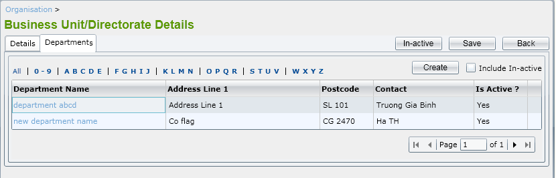

All standard behaviors in a List screen should be applied for List Departments.

The prompt message when user selecting an inactive record to view should be “Do you want to make this Department active?”

#### **Add Department**

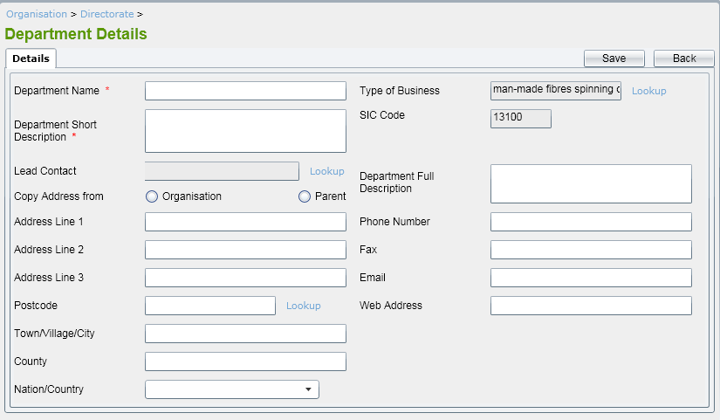

Mandatory fields should be: Department Name and Short Description.

Department Name should be unique.

Type of Business, SIC Code and Web Address fields should have defaulted values retrieved from Organisation that it belongs to.

User can enter a new Address for Department (that postcode should be verified) or click on Copy from Organisation or Parent (Directorate) that Dept. belongs to.

#### **Amend Department**

All fields in ‘Details’ tab can be editable. Validation rules are the same as adding Department.

Besides, there should be ‘Teams’ tab displaying. Refer to List Teams for more details.

#### **Mark In-active a Department**

User can mark a Department to ‘In-active’ by clicking on ‘In-active’ button on amend Department screen.

After a Department has been changed to ‘In-active’, all Teams belonging to that Department still keep their status. The in-active process is not cascade.

### **Team Maintenance**

This function includes following screen:

* List Teams
* Add Team
* Amend Team
* Mark In-active Team

They will be described in more details in sections below

#### **List Teams**

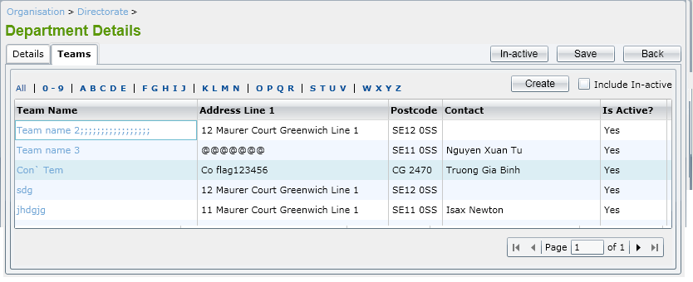

All standard behaviors in a List screen should be applied for List Departments.

The prompt message when user selecting an inactive record to view should be “Do you want to make this Team active?”

#### **Add Team**

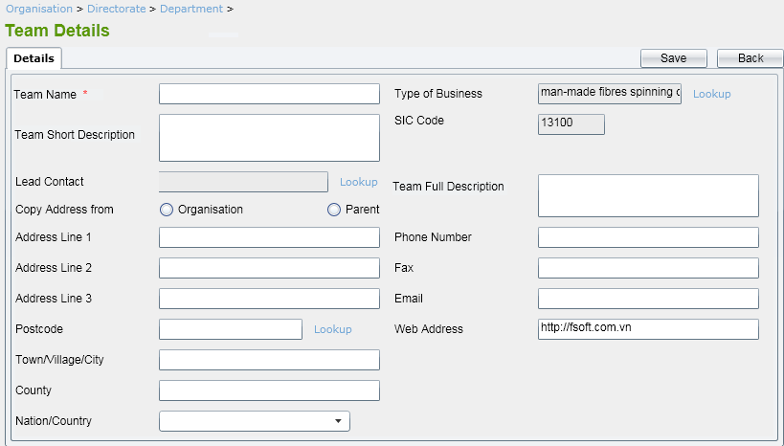

Mandatory fields should be: Team Name. This field also should be unique.

Type of Business, SIC Code and Web Address fields should have defaulted values retrieved from Organisation that it belongs to.

User can enter a new Address for Team (that postcode should be verified) or click on Copy from Organisation or Parent (Department) that Team belongs to.

#### **Amend Team**

All fields in screen can be editable. Validation rules are the same as adding Team.

#### **Mark In-active a Team**

User can mark a Team to ‘In-active’ by clicking on ‘In-active’ button on amend Team screen.

## **Services**

### **List Service**

By clicking on ‘Services’ item under Services in the menu, ‘Service List’ screen is displayed showing all active Services by default. The list is paging with 15 records showing in one page.

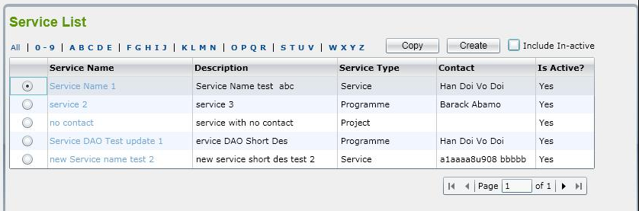

If user clicks on ‘Include In-active’ checkbox, all of active and in-active Services will be displayed in the list.

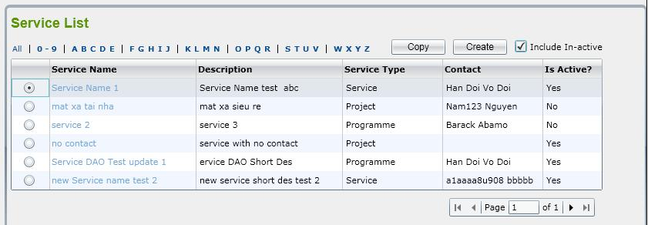

User can filter Services by selecting ‘All’ or ‘0-9’ or ‘ABCDE’ or ‘FGHIK’, etc. in a row above the list. -> All Services that begin with the selected letter will be shown.

User can sort Services by clicking on column name.

If user selects an Inactive Service in the list to view, the system will display a message “Do you want to make this Service active?”

* If clicking on ‘OK’ button, ‘Service Details’ screen is opened and system will automatically change status of Service from Inactive to Active
* If clicking on ‘Cancel’ button, it keeps ‘Service List’ screen showing and status of selected Service is still inactive.

User can copy a Service by selecting a Service and then clicking on ‘Copy’ button. After that, ‘Service Details’ screen is opened with all data of the selected Service except Service Name. Note that, similar to creating new Service, only three tabs: Details 1, Details 2, and Details 3 are showing in this case.

If user does not select a Service but clicks on ‘Copy’ button, system will display message “Please select a Service to copy”.

### **Add Service**

If user clicks on ‘Create’ button on the ‘Service List’ screen, ‘Service Details’ screen is displayed including three tabs: Details 1, Details 2 and Details 3 to allow user to enter Service fields for new one.

Below is illustration of Details 1 tab:

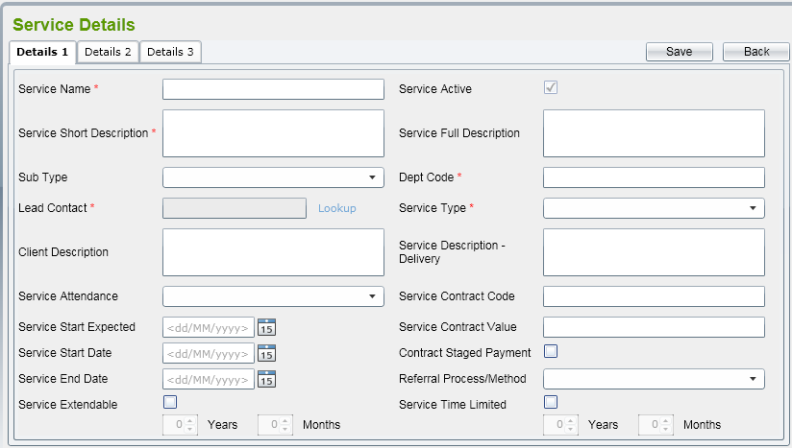

By default, all of text fields should be blank, all check boxes are un-ticked excepting Service Active.

There are some rules on this screen:

* Mandatory fields
  + Service Name
  + Service Short Name
  + Sub Type
* Unique fields
  + Service Name
* Lead Contact lookup will display all contacts in the system in a pop-up window. Refer to Contacts for more details.
* If checkbox ‘Service Extendable’ is ticked, ‘Years’ and ‘Months’ fields will be enable to user input data
* After Start Date OR End Date OR Extendable month/year  text box has lost focus, system will check Current Date with input Start Date, End Date + Extendable month/year values.
* If Service Start Date <= Current Date <= Service End Date + Extendable Month/Year -> Service Active should be auto ticked; otherwise, it should be auto un-ticked.
* In case Start Date has not be entered in the screen (NULL value), it already means that Start Date <= Current Date
* In case End Date has not be entered in the screen (NULL value), it already means that End Date >= Current Date
* In case Extendable Month/Year have not be entered (NULL values), they should be zero when comparing above
* Is user clicks on checkbox ‘Service Time Limited Period’, ‘Years’ and ‘Months’ fields will be enable to user input data
* Service Sub Type and Service Type are reference data. Refer to the spreadsheet attached in Reference Data List for more details.

If user select Service Sub Type is Contract, ‘Contract’ tab is appeared

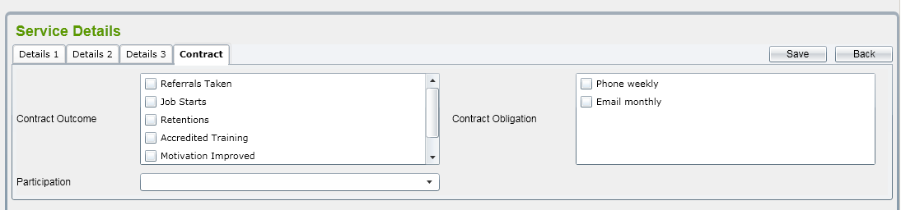

* Contract Outcome and Contract Obligation are reference data. Refer to the spreadsheet attached in Reference Data List for more details.
* Participation dropdown list includes 3 items: “Mandatory”, “Voluntary”, and “Both”.

If user selects Service Sub Type is Independently Funded, ‘Funding’ tab is appeared.

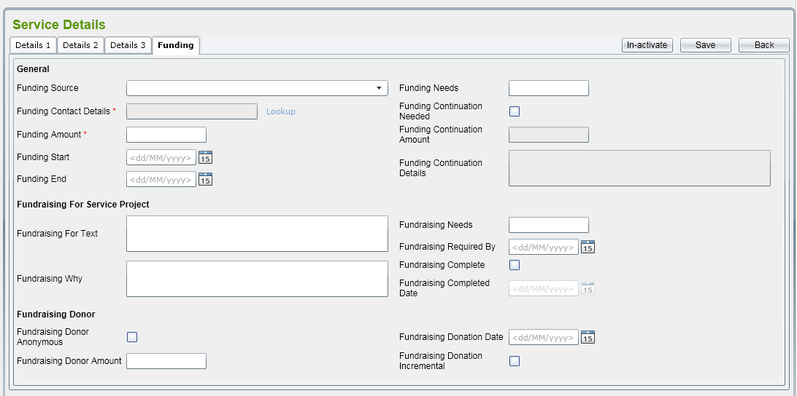

There are some rules on this screen:

* Mandatory fields
  + Funding Contact Details
  + Funding Amount
* Funding Contact Details lookup will display all contacts in the system in a pop-up window. Refer to Contacts for more details.
* When user tick on check box ‘Funding Continuation Needed’, ‘Funding Continuation Amount’ and ‘Funding Continuation Detail’ fields are enabled. Otherwise, they should be disabled.
* The format of some monetary fields (including Funding Amount, Funding Needs, Fundraising Needs, and Donor Amount) should be ‘999,999,999.99’.

‘Details 2’ tab should be as below:

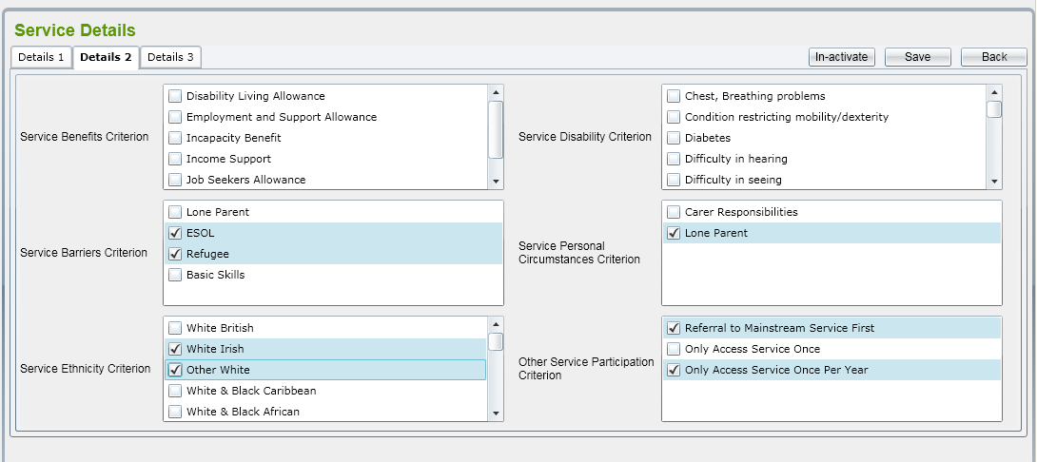

All of list boxes in this tab get from reference data. Refer to the spreadsheet attached in Reference Data List for more details.

‘Details 3’ tab should be as below:

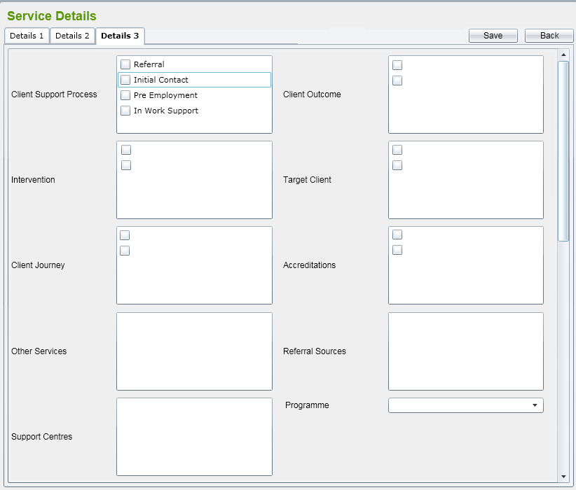

* ‘Client Support Process’, ‘Client Outcome’, ‘Target Client’, ‘Referral Sources’, ‘Support Centres’ get from reference data. Refer to the spreadsheet attached in Reference Data List for more details.
* ‘Intervention’ includes all active Interventions which have not belonged to other Service.
* ‘Other Services’ list all other active Services in the system.
* ‘Programme’ combo box list all active Programmes in the system.

To save Service record, user should click on ‘Save’ button on the screen. The system will validate mandatory fields are already input or not and check if Service Name is existed in the system.

### **Amend Service**

By selecting an active Service from the list, the Service Details screen is displaying allowing user to amend.

All fields in Details 1, Details 2, Details 3, Contract, Funding tabs can be editable.

When amending a Service, three additional tabs should be shown:

* Organisation tab:

Click on ‘Organisations’ tab, all active Organisation records in the system will be listed.

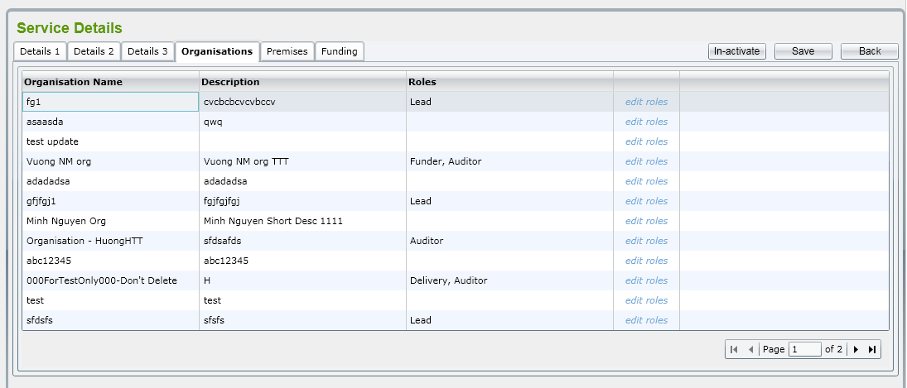

* By clicking on ‘edit roles’ link, ‘Change Roles of Organisaton’ pop-up window will be displayed with 4 roles: Funder, Lead, Delivery and Auditor

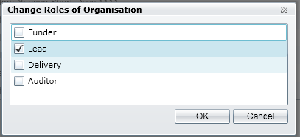

* Select roles and click on ‘OK’ button, this pop-up will be closed and selected roles will be populate in the ‘Role’ field. Each will be separate by comma
* Premises’ tab

Click on ‘Premises’ tab, list of all Premises already linked to the Service is displayed.

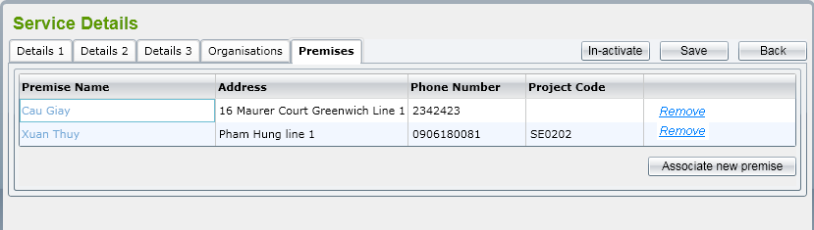

* User clicks on ‘Associate new Premise’ button, a pop-up window is displayed listing all active Premises in the system which have not linked to the Service.
* User select a Premise from the list, enter Project Code then click ‘Select’ button, the link between selected Premise and Service will be added, pop-up window is closed and the Premise list in the tab will be refreshed automatically.
* If user clicks on ‘Remove’ link on a row, the link between Premise and Service will be removed.

### **Mark In-active Service**

User can mark a Service to in-active by clicking on ‘In-active’ button on the details screen. The prompt message should be displayed: “Do you want to mark this Service in-active?”

If user clicks on ‘OK’ button, the Service will be changed status to ‘In-active’. Otherwise, it still keeps being ‘Active’.

If the Service already links to an Organisation or a Premise, the prompt message “This Service is already in use, do you want to make this in-active?” should be displayed. If user clicks ‘OK’, this Service will be marked to ‘in-active’.

### **Programme**

#### **List Programmes**

By clicking on ‘Programmes’ item under Services in the menu ‘Programme List’ screen is displayed showing all active Programmes by default.

Similar to other lists, this should have standard behaviors: displaying active/in-active, filtering, sorting, paging and marking an in-active Programme to active.

#### **Add Programme**

If user clicks on ‘Create’ button on the ‘Programme List’ screen, ‘Programme Details’ screen is displayed to allow user to enter Programme fields for new one. The interface of this screen should be below:

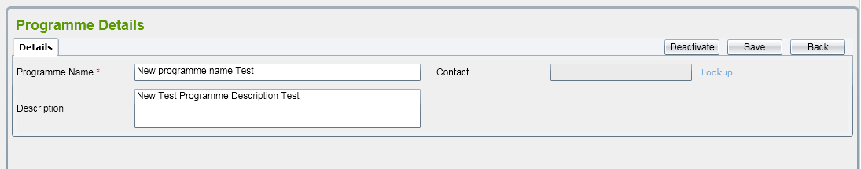

By default, all of fields should be blank. Programme Name field should be mandatory and unique.

Contact lookup will display all contacts in the system in a pop-up window. Refer to Contacts for more details.

To save Programme record, user should click on ‘Save’ button on the screen. The system will validate mandatory field are already input or not and check if Programme Name is existed in the system.

If the validation is passed, Programme record will be saved.

#### **Amend Programme**

By selecting an active Programme from the list, the Programme Details screen is displaying allowing user to amend. All fields are editable.

When user click on ‘Save’ button, all changes are saved into database

#### **Mark In-active Programme**

User can mark a Programme to in-active by clicking on ‘In-active’ button on the details screen. The prompt message should be displayed: “Do you want to make this Programme in-active?”

If the Programme already links to a Service, the prompt message should be displayed: “This Programme is already in use, do you want to make this in-active?”

If user clicks on ‘OK’ button, the Programme will be changed status to ‘In-active’. Otherwise, it still keeps being ‘Active’.

## **Geography**

### **Trust Region Maintenance**

#### **List Trust Regions**

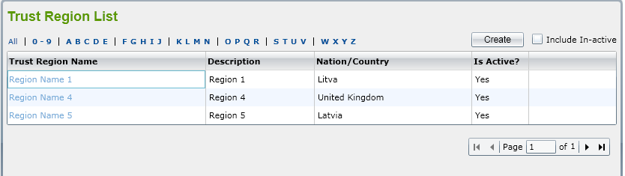

By clicking on ‘Trust Region/Trust District’ sub item under Geography in the menu, ‘Trust Region List’ screen is displayed. This list screen has all standard behavior of a list that already mentioned in Organisation module.

The prompt message when user selecting an inactive record to view should be “Do you want to make this Trust Region active?”

#### **Add Trust Region**

The screen of adding a Trust Region should be:

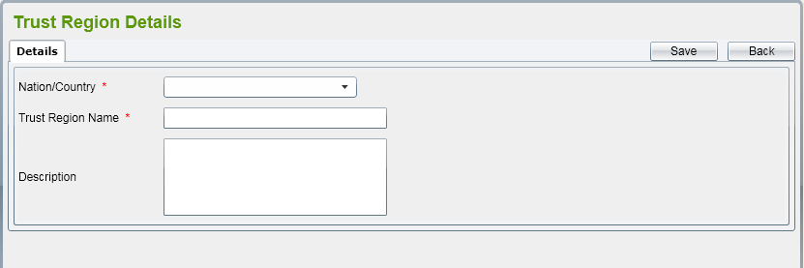

In which, Nation/Country is mandatory and user can select one from a dropdown list.

Trust Region Name is also mandatory and this field should be unique.

#### **Amend Trust Region**

All fields in Details tab can be editable.

Besides, there should be ‘Trust Districts’ tab into the Trust Region details screen.

Refer to List Trust Districts for more details.

#### **Mark In-active Trust Region**

User can mark a Trust Region to ‘In-active’ by clicking on ‘In-active’ button on amend Trust Region screen.

After a Trust Region has been changed to ‘In-active’, all Trust Districts/Trust Areas belonging to that Trust Region still keep their status. The in-active process is not cascade.

### **Trust District Maintenance**

#### **List Trust Districts**

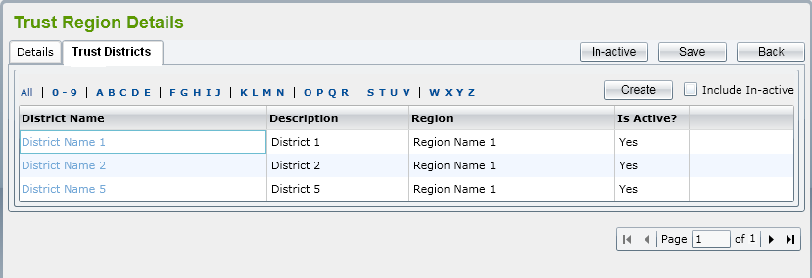

The Trust District tab should belong to a Trust Region details screen. It has all behaviors of a standard list in the system.

The prompt message when user selecting an inactive record to view should be “Do you want to make this Trust District active?”

#### **Add Trust District**

The screen should be:

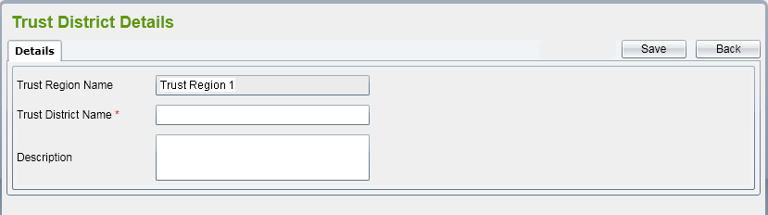

In which, Trust Region Name is read-only and shows the Trust Region that the District belongs to.

Trust District Name is mandatory and unique on each Trust Region.

#### **Amend Trust District**

User can change Trust District Name and Description.

Note that Trust District Name should be mandatory and unique on each Trust Region.

#### **Mark In-active Trust District**

User can mark a Trust District to ‘In-active’ by clicking on ‘In-active’ button on amend Trust District screen.

After a Trust District has been changed to ‘In-active’, all Trust Areas belonging to that Trust District still keep their status. The in-active process is not cascade.

### **Government Office Region**

#### **List Government Office Region**

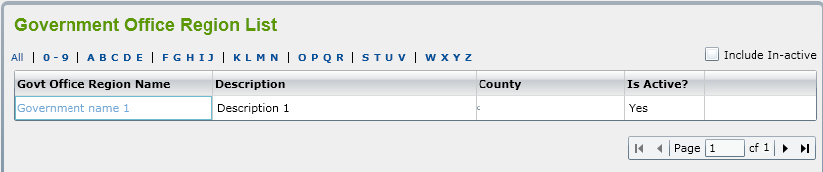

By clicking on ‘Trust Region/Trust District’ sub item under Geography in the menu, ‘Government Office Region List’ screen is displayed. This list screen has all standard behavior of a list that already mentioned in Organisation module apart from making an in-active to active.

In this phase, only list and view GORs are implemented.

#### **View Government Office Region**

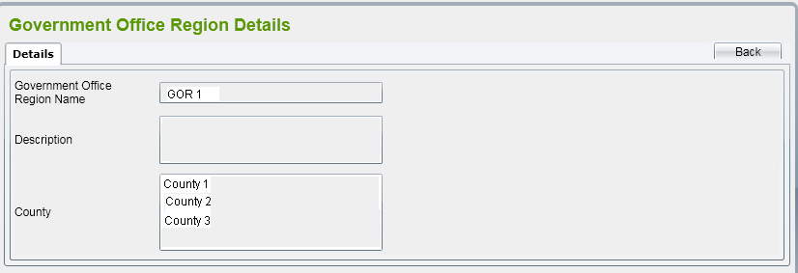

All of fields in the screen are read-only. User can clicks on ‘Back’ button to come back to the list screen.

## **Premises**

### **List Premises**

By clicking on ‘Premises’ from the menu, ‘Premise List’ screen is displayed showing all active Premises by default. The list is paging with 15 records showing in one page.

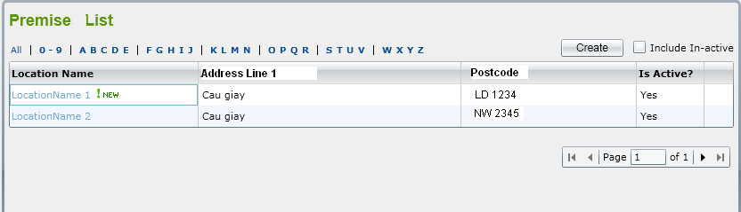

For a Premise row that is new Shop (Location Type = Shop and Current Date – Shop Flag Date < = 60 days), there should be a flag  next to Location Name field.

If user clicks on ‘Include In-active’ checkbox, all of active and in-active Premises will be displayed in the list.

User can filter Premises by selecting ‘All’ or ‘0-9’ or ‘ABCDE’ or ‘FGHIJ’, etc. in a row above the list. -> All Premises that begin with the selected letter will be shown.

User can sort Premises by clicking on column name.

If user selects an in-active Premise in the list to view, the system will display a message ‘Do you want to make this Premise active’ with 2 buttons: OK and Cancel

* If clicking on ‘OK’ button, ‘Premise Details’ screen is opened and system will automatically change status of Premise from Inactive to Active
* If clicking on ‘Cancel’ button, it keeps ‘Premise List’ screen showing and status of selected Premise is still inactive.

### **Add Premise**

If user clicks on ‘Create’ button on the ‘Premise List’ screen, ‘Premise Details’ screen is displayed including two tabs: Details 1, Details 2 and Details 3 to allow user to enter Premise fields for new one.

* Below is illustration of Details 1 tab:

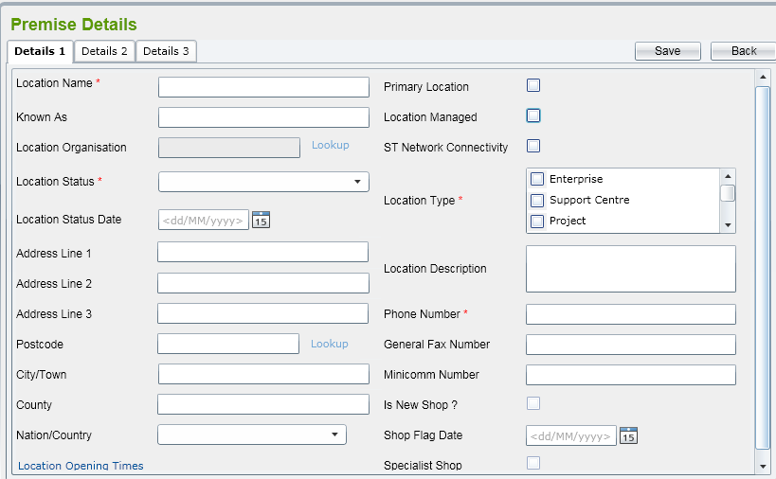

By default, all of fields should be blank, all check boxes are un-ticked.

There are some rules on this screen:

* Mandatory fields
  + Premise Name
  + Location Name
  + Location Type
  + Location Status
  + Phone Number
* Unique fields
  + Combination of Premise Name AND Address Line 1 AND Postcode
* Location Status should be selected from a combo box including Pending Active, Active, Pending Closure, and Closed items.
* User can select one or more Location Types. They are reference data – refer to the spreadsheet attached in Reference Data List for more details.
* Location Organisation lookup will display all contacts in the system in a popup window. Refer to Organisations for more details.
* Postcode lookup will display all addresses retrieved from PAF database in a popup window. Refer to Address for more details. The verify Address basing on PAF is the same as mentioned in Organisation module.
* Click on ‘Location Opening Times’ link -> ‘Location Open Days’ popup is displayed and allow uer select day and open time

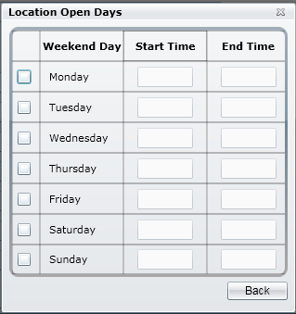

By default, Monday, Tuesday, Wednesday, Thursday and Friday are checked, and Start Times should be 9:00, End Times should be 17:00. User can tick/un-tick and edit time manually then.

* If user selects Location Type = Shop, ‘Is New Shop’, ‘Shop Flag Date’ and ‘Specialist Shop’ fields are enable. If Current Date – Shop Flag Date < = 60 days, the system will be automatically tick on checkbox ‘Is New Shop’
* ‘Details 2’ tab should be as below:

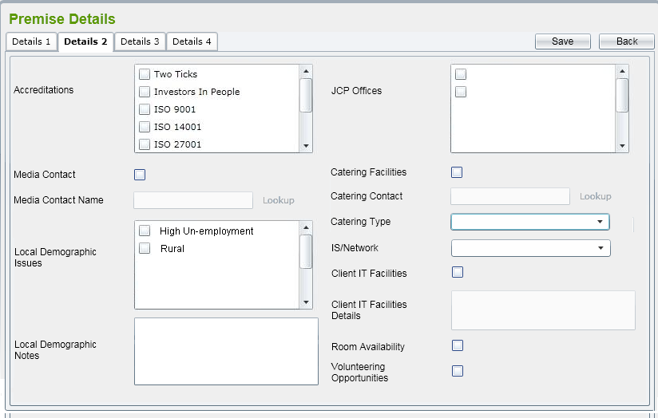

* By default, all text fields should be blank, all check boxes should be un-ticked.
* Accreditations should be reference data. Refer to the spreadsheet attached in Reference Data List for more details.
* JSP Offices list all active Premises having Location Type = ‘JCP Offices’
* If ‘Media Contact’ is ticked, ‘Media Contact Name’ field is enabled. Otherwise, it should be disabled.
* Media Contact Name lookup will display all contacts in the system in a popup window. Refer to Contacts for more details.
* If ‘Catering Facilities’ is ticked, ‘Catering Contact’ and ‘Catering Type’ fields are enabled. Otherwise, it should be disabled.
* Catering Contact lookup will display all contacts in the system in a popup window. Refer to Contacts for more details.
* Catering Type is reference data. Refer to the spreadsheet attached in Reference Data List for more details.
* Local Demographic Issues is reference data. Refer to the spreadsheet attached in Reference Data List for more details.
* IS/Network is reference data. It should include ‘Open’, ‘Wip’, and ‘Closed’ items.
* If ‘Client IT Facilities’ is ticked, ‘Client IT Facilities Details’ field is enabled. Otherwise, it should be disabled.
* ‘Details 3’ tab should be as below:

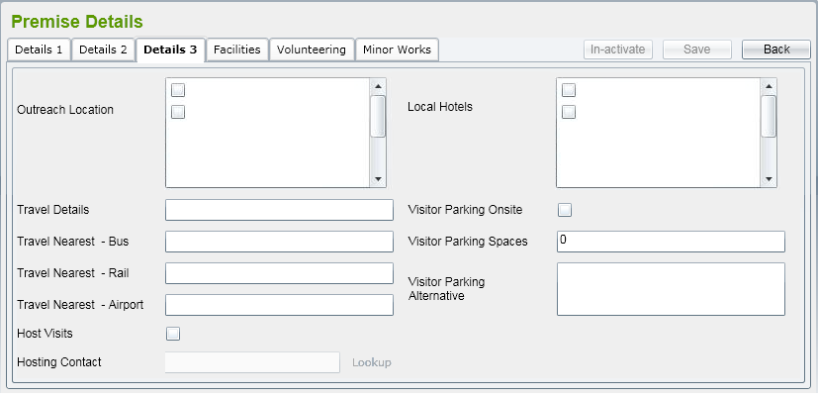

* Outreach Location list all active Premises having Location Type = ‘Outreach Location’.
* Local Hotel list all active Premises having Location Type = ‘Hotel’.
* If ‘Host Visits’ is ticked, ‘Hosting Contact’ field is enabled. Otherwise, it should be disabled.
* Hosting Contact lookup will display all contacts in the system in a popup window. Refer to Contacts for more details.
* If ‘Visitor Parking Onsite’ is ticked, ‘Visitor Parking Spaces’ field is enabled, ‘Visitor Parking Alternative’ field is disabled.

If ‘Visitor Parking Onsite’ is unticked, ‘Visitor Parking Alternative’ field is enabled, ‘Visitor Parking Spaces’ field is disabled.

* If in Details 1 tab, user selects Location Type to Venue or Hotel, ‘Details 4’ tab will be appreared and navigated to.

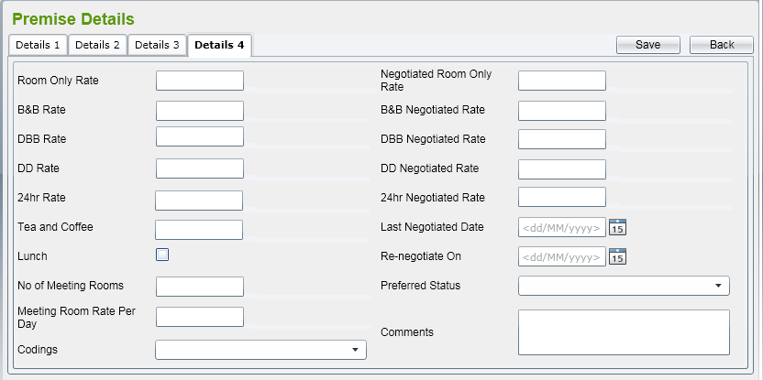

* In this screen, all of moneytary fields (including Rates fields and Tea and Coffee cost) should have format like ’99,999.99’ (£)

To save Premise record, user should click on ‘Save’ button on the screen. The system will validate mandatory fields are already input or not and check if Premise Name is existed in the system.

If the validation is passed, Premise record will be saved and Premise details screen is kept to allow user to add Facilities, Volunteering Opportunities, Minor Works Project, and link to Services if necessary. Message to inform the successful saving should be displayed as well.

### **Amend Premise**

By selecting an active Premise from the list, the Premise Details screen is displaying allowing user to amend. All fields in Details tabs are editable.

If user ticks on ‘Volunteering Opportunities’ in Details 2 tab, it should navigate to Volunteering tab automatically.

In Edit mode, user can see Facilities, Volunteering (if ‘Volunteering Opportunities’ in Details 2 tab is already ticked), Minor Works, and Services tabs. They will be described in more details below.

After clicking ‘Save’ button, all changes are saved into database.

### **Mark In-active Premise**

User can mark Premise to in-active by clicking on ‘In-active’ button on the details screen. The prompt message should be displayed ‘Do you want to make this Premise in-active?’

If user clicks on ‘OK’ button, the Premise will be changed status to ‘In-active’. Otherwise, it still keeps being ‘Active’.

### **Facility Maintenance**

List Facilities

In Premise Details screen of an active Premise, user can navigate to Facilities list by clicking on ‘Facilities’ tab.

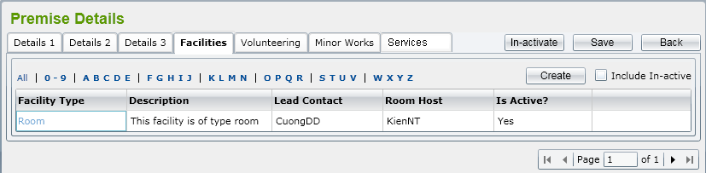

Similar to other lists, this should have standard behaviors: displaying active/in-active, filtering, sorting, paging and marking an in-active Facility to active.

Add Facility

If user clicks on ‘Create’ button on the ‘Facilities’ tab, ‘Facility Details’ screen is displayed to allow user to enter Facility fields for new one.

Below is illustration of Facility Details:

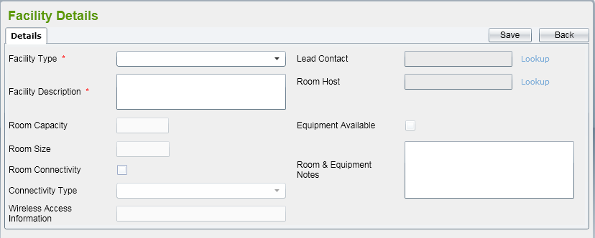

* By default, all of fields should be blank, all check boxes are un-ticked.
* Facility Type is reference data, refer to the spreadsheet attached in Reference Data List for more details.
* If Facility Type is ‘Room’, Room Capacity, Room Size, Room Connectivity, Equipment Available, Room & Equipment Notes fields are enabled. Otherwise, those fields should be disabled.
* If Facility Type is ‘Internet Access’, Connectivity Type is enabled.
* If Room Connectivity is ticked, Room Connectivity Type field is enabled.
* Lead Contact lookup will display all contacts in the system in a popup window. Refer to Contacts for more details.
* Room Host lookup will display all contacts in the system in a popup window. Refer to Contacts for more details.
* If Equipment Available is ticked, a text box next to that field is shown and then user can enter the equipment name there.
* If Room Size and Room Capacity are enabled, they should be numeric and in rage from 0 to 9999.

To save Facility record, user should click on ‘Save’ button on the screen.

If user clicks on ‘Back’ button, it should come back to ‘Facilities’ tab.

Amend Facility

By selecting an active Facility from the list, the Facility Details screen is displaying allowing user to amend.

After clicking ‘Save’ button, all changes are saved into database

Mark In-active Facility

User can mark a Facility to in-active by clicking on ‘In-active’ button on the details screen. The prompt message should be displayed ‘Do you want to make this Facility in-active?’

If user clicks on ‘OK’ button, the Facility will be changed status to ‘In-active’. Otherwise, it still keeps being ‘Active’.

### **Volunteering Opportunity**

List Volunteering Opportunity

In Premise Details screen of an active Premise that has ‘Volunteering Opportunities’ in Details 2 tab is already ticked, user can navigate to Volunteering Opportunities list by clicking on ‘Volunteering’ tab.

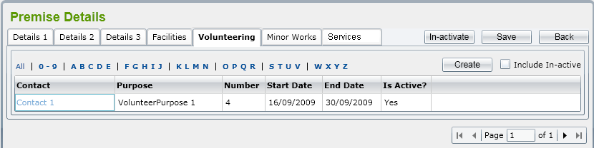

Similar to other lists, this should have standard behaviors: displaying active/in-active, filtering, sorting, paging and marking an in-active Volunteering Opportunity to active.

Add Volunteering Opportunity

If user clicks on ‘Create’ button on the ‘Volunteering Opportunity List’ screen, ‘Volunteering Opportunity Details’ screen is to allow user to enter Volunteering Opportunity fields for new one.

Below is illustration of Volunteering Opportunity Details:

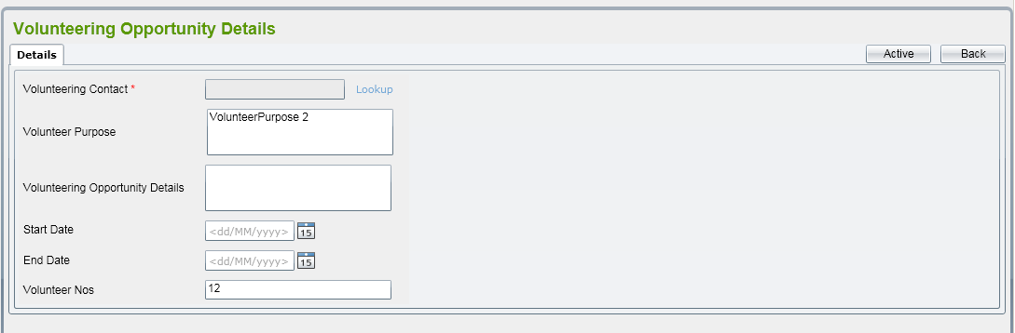

There are some rules on this screen:

* By default, all of fields should be blank, all checkboxes are un-ticked.
* Mandatory fields: Volunteering Contact
* Volunteering Contact lookup will display all contacts in the system in a popup window. Refer to Contacts for more details.
* End Date must not be before Start Date.
* Volunteer Nos: must be numeric an in range from 0 to 9999.

To save Volunteering Opportunity record, user should click on ‘Save’ button on the screen.

If user clicks on ‘Back’ button, it should come back to ‘Volunteering’ tab.

Amend Volunteering Opportunity

By selecting an active Volunteering Opportunity from the list, the Volunteering Opportunity Details screen is displaying allowing user to amend.

After clicking ‘Save’ button, all changes are saved into database

Mark In-active Volunteering Opportunity

User can set a Volunteering Opportunity to in-active by clicking on ‘In-active’ button on the details screen. The prompt message should be displayed ‘Do you want to make this Volunteering Opportunity in-active?’

If user clicks on ‘OK’ button, the Volunteering Opportunity will be changed status to ‘In-active’. Otherwise, it still keeps being ‘Active’.

### **Minor Work Projects**

List Minor Work Project

In Premise Details screen of an active Premise, user can navigate to Minor Works Projects list by clicking on ‘Minor Works’ tab.

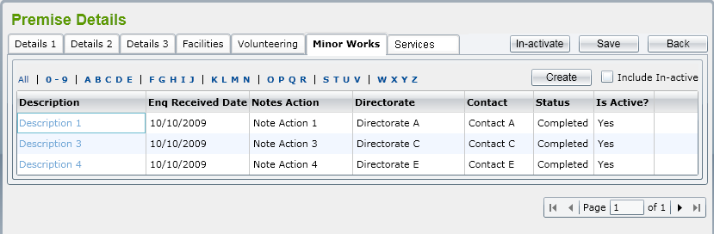

Similar to other lists, this should have standard behaviors: displaying active/in-active, filtering, sorting, paging and marking an in-active Minor Works Project to active.

Add Minor Works Project

If user clicks on ‘Create’ button on the ‘Minor Works Project List’ screen, ‘Minor Works Project Details’ screen is to allow user to enter Minor Works Project fields for new one.

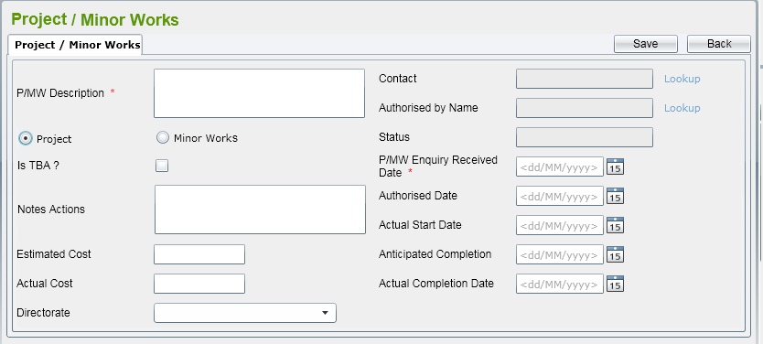

There are some rules on this screen:

* By default, all of fields should be blank, all check boxes are un-ticked. Project radio box is checked.
* Mandatory fields
  + P/MW Date Enquiry Received
  + P/MW Description
  + P/MW Contact
* Contact lookup will display all contacts in the system in a popup window. Refer to Contacts for more details.
* If user ticks on ‘Is TBA?’, user is forced to enter Notes Actions field and Estimates Cost is disabled. Otherwise, Estimated Cost is enabled.
* User can select a Directorate by clicking on Directorate combo box. This combo box will be displayed all active Directorates that exsist in the database
* Status is read-only field. It should be:
* ‘Work Not Started’ where there is No Start Date or the Actual Start Date is after the current date
* ‘Work in Progress’ if there is an Actual Start Date that is before the current date and there is no Actual Completion date
* ‘Work Completed’ where Actual Completion Date has been entered and it is before the current date.
* Authorised Date must be >= Enquiry Received Date
* Actual Start Date must be >= Authorised Date
* Anticipated Completion Date must be >= Enquiry Received Date
* Actual Complete Date must be >= Actual Start Date

To save Minor Work Project record, user should click on ‘Save’ button on the screen.

If user clicks on ‘Back’ button, it should come back to ‘Minor Works’ tab.

Amend Minor Work Project

By selecting an active Minor Works Project from the list, the Minor Works Project Details screen is displaying allowing user to amend.

After clicking ‘Save’ button, all changes are saved into database

In-active Minor Work Project

User can mark a Minor Works Project to in-active by clicking on ‘In-active’ button on the details screen. The prompt message should be displayed ‘Do you want to make this Minor Works Project in-active?’

If user clicks on ‘OK’ button, the Minor Work Project will be changed status to ‘In-active’. Otherwise, it still keeps being ‘Active’.

### **Services**

The tab will list all Services have already linked to the Premise. It will look like:

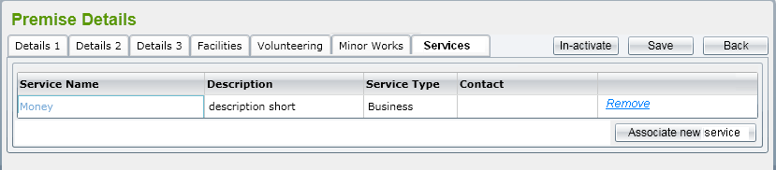

* User clicks on ‘Associate new Service’ button, a pop-up window is displayed listing all active Services in the system which have not linked to the Premise.
* User select a Service from the list, enter Project Code then click ‘Select’ button, the link between selected Service and Premise will be added, pop-up window is closed and the Service list in the tab will be refreshed automatically.

If user clicks on ‘Remove’ link on a row, the link between Service and Premise will be removed.

## **Contacts**

This function is to list, add new or edit a Contact person in the system. Contact Maintenance will be represented in a pop-up window and called from an Organisation, Directorate, etc. the details screen that need to fill a person as its contact.

### **List Contacts**

Below is illustration of List Contacts screen:

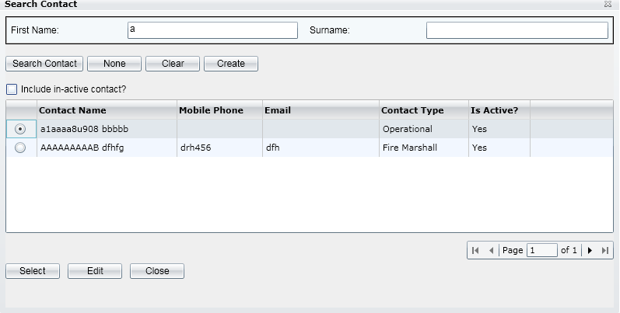

User can enter First Name or Surname to relevant text boxes for filtering the Contacts. The application will search all Contacts records which have Name beginning with input data into First Name or Surname.

By default, the list will include all active Contact but if user ticks on Include in-active contact check box, this will return active and in-active records both.

### **Add Contacts**

User can create new a Contact by clicking on ‘Create’ button on the pop-up window. The Contact screen should look like below:

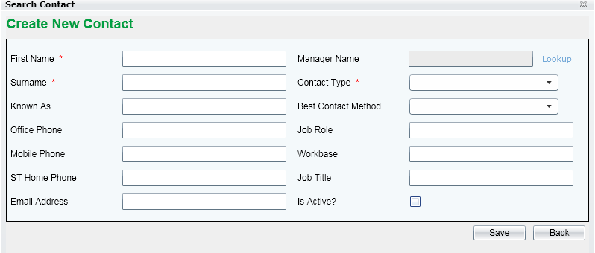

In which, First Name, Surname and Contact Type are mandatory fields.

Contact Type and Best Contact Method are reference data can be get from reference data

User can set Manager of the Contact by click on Lookup link and then it will show another Search Contact pop-up window to select a Contact.

To set a Contact being Active or In-active, user can tick/un-tick the relevant check box in the screen.

### **Edit Contacts**

User can edit a Contact by clicking on ‘Edit’ below the list. The Contact details screen look like the same as illustration on Add Contact above.

## **Address lookup**

This function is to list addresses queried from the database for populate an address to Organisation, Directorate, etc. record in SD system. The input criteria can be postcode, street or town. After user select an Address in the result list, all of Address fields: Address lines 1-3, Postcode, Town, County, and Country will populate to the screen which are retrieved.

The Search Address pop-up window should be shown as below:

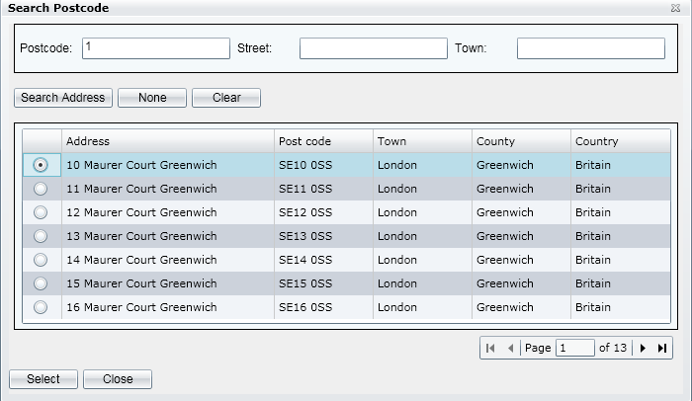

If user inputs some criteria such as Postcode, Street, and Town and then clicks on ‘Search Address’ button, it will list all address in the database mapped with filtered conditions.

If user select’ an Address row and then clicks on ‘Select’ button, the selected Address fields will be populated to related text boxes in the screen that called Search Address.

If user clicks on ‘None’ button, the pop-up window will be closed and all previous address fields in the calling screen will be blank.

If user clicks on ‘Clear’ button, the input criteria in the screen will be cleared.

If user clicks on ‘Close’ button, the pop-up window will be closed.

## **Type of Business lookup**

This lookup to show SIC code that need to be attached for an Organisation, Directorate, Department or a Team. Data list will be stored in SD database (Reference data) that copied from “SIC2007Indexes.xls”

The screen should be:

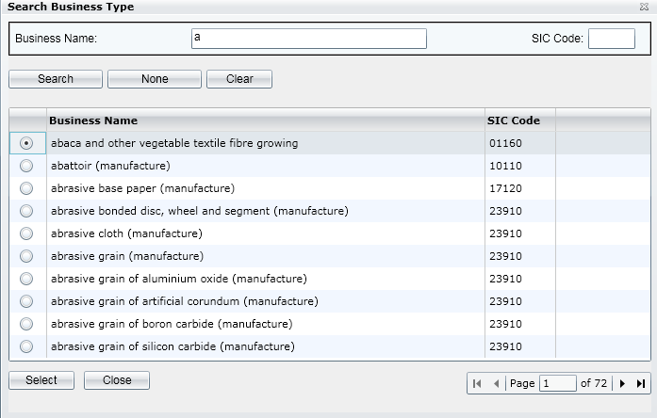

User must enter Business Name before searching to limit the returned records.

# **Non-functional requirements**

## **Performance**

|  |  |
| --- | --- |
| **Requirements relating to Performance** | |
| **No.** | **Requirement** |
| 1. | As FPT practical, with testing environment in offshore as below:  Server: CPU – Intel Pentium4 3.0GHz, RAM – 4GB, HDD-160GB, OS-Window Server 2003 SP1  Client: CPU – Intel Pentium4 2.4GHz, RAM – 1GB, HDD-40GB, OS-Window XP SP2  Response time for SD system should meet following:   * For add new functions (assumed that there are average 30 fields need to update to DB), the response time should be in a range of 3-5 seconds. For the first time to query the page, it takes longer than the following ones. It’s approximately about 10 seconds. The following calls should be less than 5 seconds * For list/view functions (assumed that there will be around 1000 records displayed), the response time should be in a range of 7-10 seconds. For the first call might take about 15 seconds. The following calls should be less than 10seconds * For all validation data logic, the response time shouldn’t take than 2 seconds |
| 2 | With mentioned server above, Service Directory system should cover the load of 20-50 concurrent users. |

## **Scalability**

|  |  |
| --- | --- |
| **Requirements relating to Scalability** | |
| **No.** | **Requirement** |
| 1. | It must scale to the expected number of users for SD system |

## **Security**

|  |  |
| --- | --- |
| **Requirements relating to Security** | |
| **No.** | **Requirement** |
| 1. | Just use standard authentication and authorization mechanism |

## **Portability**

|  |  |
| --- | --- |
| **Requirements relating to Security** | |
| **No.** | **Requirement** |
| 1. | For the up-coming release, the Service Directory is expected to work with Internet Explorer version 6.0 or later and Firefox. |

## **Audit**

|  |  |
| --- | --- |
| **Requirements relating to Audit** | |
| **No.** | **Requirement** |
| 1. | None required at present. |

## **Error handling**

|  |  |
| --- | --- |
| **Requirements relating to Error handling** | |
| **No.** | **Requirement** |
| 1. | Proactive notification of problems. System must provide sufficient context in the notification to assist in the diagnosis and repair of the problem. Varying levels of notification will be needed for different classes of error for instances: logging errors to log files, logging errors to event viewer, sending emails. |

## **Infrastructure**

|  |  |
| --- | --- |
| **Requirements relating to Infrastructure** | |
| **No.** | **Requirement** |
| 1. | All services inside Service Directory are expected to be hosted under https for security purposes. Shaw-trust to confirm if they can provide an appropriate SSL infrastructure. |

## **Look and feel**

|  |  |
| --- | --- |
| **Requirements relating to Look and feel** | |
| **No.** | **Requirement** |
| 1. | See section 6. The look and feel should also be similar to the screen mock-ups provided with the FRS for new ‘CID’ and should have the same feel as MS Dynamics. |

## **Legal**

|  |  |
| --- | --- |
| **Requirements relating to Legal issues** | |
| **No.** | **Requirement** |
| 1. | None required at present. |

## **Training**

|  |  |
| --- | --- |
| **Requirements relating to Training** | |
| **No.** | **Requirement** |
| 1. | None required at present. |

## **User Documentation & Help Screen Requirements**

|  |  |
| --- | --- |
| **Requirements relating to User Documentation** | |
| **No.** | **Requirement** |
| 1. | An icon will be provided in the corner of each screen that can be clicked to load a page of help for that screen. The help text will be maintained by Shawtrust. This is in scope of Phase 2 |

## **Support & Supportability**

|  |  |
| --- | --- |
| **Requirements relating to Support** | |
| **No.** | **Requirement** |
| 1. | Fully support during UAT and 3 month warranty support |

## **Reliability**

|  |  |
| --- | --- |
| **Requirements relating to Reliability** | |
| **No.** | **Requirement** |
| 1. | Availability: The Service Directory is expected to run all the time 24 hours a day and 7 day a week without service failing to respond. There should be no un-handled Exception to be occurred inside the Services. |

## **Design Constraints**

|  |  |
| --- | --- |
| **Requirements relating to Design** | |
| **No.** | **Requirement** |
| 1. | The design must take this requirement into consideration for everything that the system may do and how this could be supported |
| 2. | The design must follow principles for design in CID system |

## **Purchased Components**

|  |  |
| --- | --- |
| **Requirements relating to Components** | |
| **No.** | **Requirement** |
| 1. | None required at present. |

## **Interfaces**

|  |  |
| --- | --- |
| **Requirements relating to Interfaces** | |
| **No.** | **Requirement** |
| 1. | None required at present. |

## **Test**

|  |  |
| --- | --- |
| **Requirements relating to Testing** | |
| **No.** | **Requirement** |
| 1. | None required at present. |

## **Data**

|  |  |
| --- | --- |
| **Requirements relating to Data** | |
| **No.** | **Requirement** |
| 1. | None required at present. |